 | чЕРНІГІВСЬКИЙ Центр перепідготовки та підвищення кваліфікації працівників органів державної влади, органів місцевого самоврядування, державних підприємств, установ і організацій

ENGLISH FOR SPECIFIC PURPOSES. Методичні вказівки з англійської мови для державних службовців, керівників, менеджерів



Чернігів - 2019
ENGLISH FORSPECIFIC PURPOSES. Методичні вказівки з англійської мови для державних службовців, керівників, менеджерів / Укл.: Навчально-методичний збірник / Чернігівський центр перепідготовки та підвищення кваліфікації працівників органів державної влади, органів місцевого самоврядування, державних підрозділів, установ і організацій. Укладач: Н. В. Гагіна: Чернігів: ЦППК, 2019. – 44 с.

Рекомендовано до видання навчально-методичною радою Чернігівського Центру перепідготовки та підвищення кваліфікації працівників органів державної влади, органів місцевого самоврядування, державних підприємств, установ і організацій, протокол №1 від 22 лютого 2019 року.

Укладач: | Гагіна Наталія Вікторівна – викладач Чернігівського технологічного університету, кандидат педагогічних наук.

© Чернігівський центр перепідготовки та підвищення кваліфікації працівників органів державної влади, органів місцевого самоврядування, державних підприємств, установ і організацій, 2019

ЗМІСТ

Unit 1
PUBLIC ADMINISTRATION AND CIVIL SERVICE…………………………..…4

Unit 2
MANAGEMENT...…………………………………………………………………...8

Unit 3
MOTIVATION………………………………………………………………...…….14

Unit 4
RECRUITMENT…………………………………….………………………………18

Unit 5
MANAGING ACROSS CULTURES………………………………………….....…26

Unit 6
TEAM BUILDING………………………………………………………….……….32

Unit 7
CRISIS MANAGEMENT ..…………………………………………………………36

РЕКОМЕНДОВАНА ЛІТЕРАТУРА…………………………….………….….…44

Unit 1 Public administration and civil service

Lead-in
What is public administration?
What is civil service?
What are functions of civil servants?

1. Read the text about public administration and civil service.
Public administration is a feature of all nations whatever their system of government is. It is usually associated with government employment and bureaucracy and is found whenever there is a need to manage large numbers of people and tasks. Today public administration is often regarded as including also some responsibility for determining the policies and programs of governments. Specifically, it is the planning, organizing, directing, coordinating, and controlling of government operations. Traditionally defined, public administration is the process of managing public affairs on both national and local levels in accordance with the laws adopted by the legislature and the executive branch of government. It deals with execution of public policies and government programs to achieve better qualitative and quantitative indicators of economic, social and cultural health of the country.
The body responsible for public administration of a country is called the civil service. The civil service is known to be the administrative service in government. Public administration is a broader term than thecivil service because it does not limit itself to management, but incorporates all of the political, social, cultural and legal environments that affect the managing ofpublic institutions. National laws and policies are put into effect bycivil servants - people of different occupations including economists, lawyers, engineers, social workers, public relations specialists, computer programmers, etc., who work in a great number ofgovernment agencies, departments and offices. So, public servants are government employees who are directly involved in carrying out public policies and making all kinds of decisions, from minor details (garbage disposal or street lightening) to the fundamental issues of that policy (regulation of economy or pollution control).Public policy is a plan of action adopted by government to fully meet public interests and people’s needs in various fields, such as education, economy, welfare, housing, and many others.
Certain characteristics are common to all civil services. Senior civil servants are regarded as the professional advisers to those who formulate state policy. Civil servants in every country are expected to advise, warn, and assist those responsible for state policy and, when this has been decided, to provide the organization for implementing it.
The civil service is contrasted with other agencies serving the state full time such as military, judiciary and the police. In most countries a distinction is also made between the home civil service and those persons engaged abroad on diplomatic duties.
The legal framework within which public administration is carried out is the administrative law. The administrative law covers the organization, the powers, the liabilities as well as the duties and functions of public authorities engaged in administrative practices at all levels. It also regulates the relations of public bodies with one another, with non - governmental organizations and citizens. The relations of central government departments and local authorities are also under jurisdiction of the administrative law.

2.Match up the following words and definitions.
a) administration | 1. the executive policy-making body of a country or locality
b) government | 2. the act or process of administering
c) legislature | 3. plan of action adopted by government to meet public interests
d) bureaucracy | 4. rule or set of rules regulating life of society and its members
e) public policy | 5 elected or appointed government officials making public policy

3. Fill in the correct preposition.
1) associated ____ government employment
2) contrasted ____ other bodies
3) carried ____ ____ civil servants
4) engaged _____ administrative practices
5) a distinction ____civil and military service
6) common ____ all civil services
7) in accordance _____ something

4. Use the word combinations in the box to complete the text below. There is one extra word combination you do not have to use.
public order and safetymilitary or constabulary public service the judiciary and the police meet interests warn and assistpolicies and programsinternal affairsgovernmental naturegovernment policy
Public Administration can be broadly described as the development, implementation and study of (1) ___. Public administration is also an academic discipline that studies this implementation and prepares civil servants for working in the (2) ___.
Today public administration is often regarded as including also some responsibility for determining (3) ___ of governments. Specifically, it is planning, organizing, directing, coordinating, and controllingof government operations.
Public administration comprises establishments primarily engaged in activities of a (4) ___, that is, the enactment and judicial interpretation of laws and their pursuant regulations, and the administration of programs based on them. This includes legislative activities, taxation, national defense, (5) ___, immigration services, foreign affairs and international assistance, and the administration of government programs.
The body of public administrators is usually called the civil service. Traditionally the civil service is contrasted with other bodies serving full time, such as the military, (6) ___. In most countries a distinction is also made between the home civil service and those persons engaged abroad on diplomatic duties. A civil servant (civil service employee), therefore, is oneof a body of persons who are directly employed in the administration of the (7) ___ of the state and whose role and status are not political, ministerial, (8) ___.
Certain characteristics are common to all civil services. Senior civil servants are regarded as the professional advisers to those who formulate state policy. Civil servants in every country are expected to advise, (9) ___ those responsible for state policy and, when this has been decided, to provide the organization for implementing it.

5. Read the text and speak on the principles of good governance.
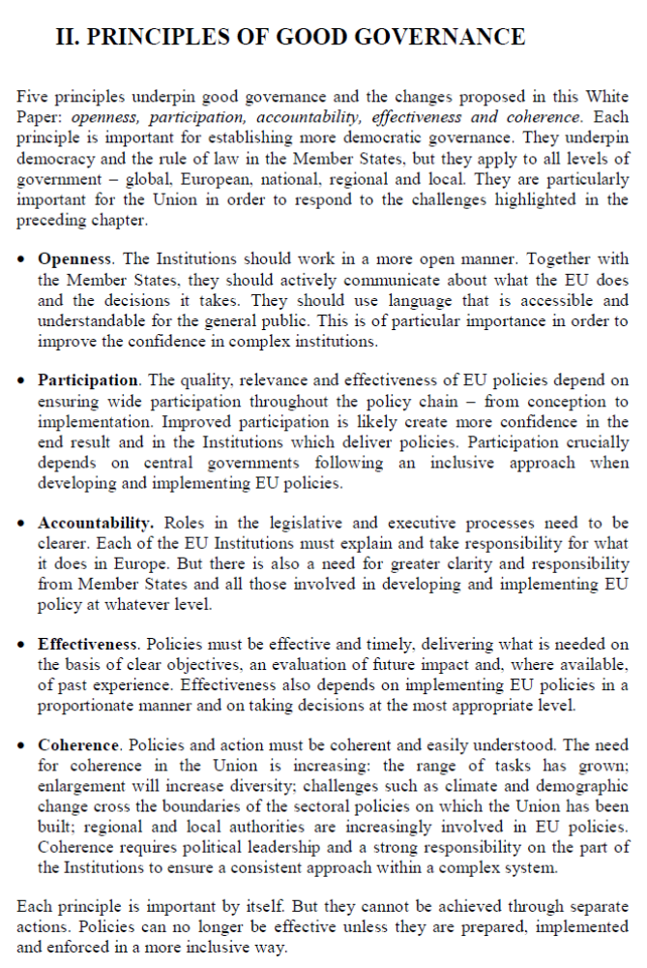
6. Complete the sentences.
1. Public administration is the processof ___________ public ____________.
2. A civil servant is a government __________ who is directly involved in __________ ______ ________ ________ and _________ all kinds of ____________ to improve the quality of people’s life.
3. In most countries a distinction is made between the ________ ________ _________ and those persons ___________ ____________ on diplomatic duties.
4. The administrative law regulates the _________ of _________ _________ with one another, with non -governmental ____________ and ___________.
5. Public policy is a ________ of ________ adopted by _________ to fully _________ _________ _________ and _________ __________ in various fields.

7. Watch the video and answer the questions.

Ukraine's E-Governance Future
https://www.youtube.com/watch?v=nD-pZGR6wL0

1. What do e-services include?
2. How will e-governance help combat endemic corruption in Ukraine?
3. What is the percentage of internet usage in Ukraine?
4. What are the key obstacles to using information communication technologies in Ukraine?
5. What does the Ukrainian-Swiss e-governance programme include as the key components?

1 enable робитиможливим | 17 participatory спільний
2 licence дозвіл | 18 decision making прийняттярішення
3 obtain a licence отримуватидозвіл | 19 engage citizensзалучатигромадян
4 transparency прозорість, відкритість | 20 interact (with) взаємодіяти
5 endemic corruption повальнакорупція | 21 online environment онлайнсередовище
6 tackleенергійнобратися (за справу) | 22 ranking рейтинг
7 draft law законопроект | 23 score набиратибали
8 procurement закупівля | 24 GDP gross domestic product
9 putthroughвиконати, завершити (роботу) | валовийвнутрішнійпродукт
10 scale up поступовозбільшувати | 25 improve вдосконалювати, покращувати
11 approach підхід | 26 voting голосування
12 tax податок | 27 election campaign виборчакампанія
13 literacy грамотність, компетентність | 28crowdfundingгромадськефінансування
14 penetration проникнення, розповсюдження | 29 abuse зловживання
15 capacity здатність | 29 transaction ділова (комерційна) операція
16 interconnection взаємозв’язок | 29 transaction ділова (комерційна) операція

8. Discussion.

What are the main problems of public administration in Ukraine? What is the core of these problems?

Unit 2 Management

Lead-in
What is management?
What do you think are the most important characteristics of a good manager?
Are good managers born or made?

1. Read the text about different functions of management.
Peter Drucker, an American business professor and consultant, who is often called ‘The Father of Modern Management’ suggested that the work of a manager can be divided into five tasks: planning (setting objectives), organizing, integrating (motivating and communicating), measuring performance, and developing people.  First of all, senior managers and directors set objectives, and decide how their organization can achieve or accomplish them. This involves developing strategies, plans and precise tactics, and allocating resources of people and money. | 
Secondly, managers organize. They analyse and classify the activities of the organization and the relations among them. They divide the work into manageable activities and then into individual tasks. They select people to perform these tasks.
Thirdly, managers practice the social skills of motivation and communication. They also have to communicate objectives to the people responsible for attaining them. They have to make the people who are responsible for performing individual tasks form teams. They make decisions about pay and promotion. As well as organizing and supervising the work of their subordinates, they have to work with people in other areas and functions.
Fourthly, managers have to measure the performance of their staff, to see whether the objectives or targets set for the organization as a whole and for each individual member of it are being achieved.
Lastly, managers develop people – both their subordinates and themselves.
A company’s top managers also have to consider the future, and modify or changes the organization’s objectives when necessary, and introduce the innovations that will allow the business to continue. Top managers also have to manage business’s relations with customers, suppliers, distributors, bankers, investors, neighbouring communities, public authorities, and so on, as well as deal with any crisis that arises.
Although the task of a manager can be analysed and classified in this fashion, management is not entirely scientific. There are management skills that have to be learnt, but management is also a human skill. Some people are good at it, and others are not. Some people will be unable to put management techniques into practice. Others will have lots of technique, but few good ideas. Excellent managers are quite rare.

2. Match up the following words and definitions.
1 subordinate | A an ability that is required to do a job
2 crisis | B a plan for achieving success
3 innovation | C a person who is of lower rank or position
4 objective | D a person who provides expert advice to a company
5 promotion | E something new that has been introduced
6 skill | F something you plan to do or achieve
7 strategy | G a situation of great danger or difficulty
8 consultant | H when someone is raised to a higher or more important position

3. Use the word combinations in the box to complete the sentences below. There is one extra word combination you do not have to use.
deal with crises introduce innovations develop strategies perform tasks allocate resources make decisions measure performance supervise subordinates set objectives select people

1. There is probably nothing more important to the future of an organization than to ___ the right ___ for positions of authority.
2 To ___ your ___, you need to know how to set them.
3. Some people ___ ___ better on their own while others work better in teams.
4. After an organization has ___ ___, it has to make sure that it achieves them.
5. Top managers have to be prepared to ___ ___ ___ if they occur and then have to ___ quick ___.
6. Managers have to find the best way to ___ all the human, physical and capital ___ available to them.
7. Managers ___ the work of their ___ and try to develop their abilities.
8. Research is necessary to solve common operating problems and to ___ ___.
9. Managers ___ the ___ of their staff to see whether they are reaching their targets.

4. Complete the text using the correct form of these verbs: achieve, allocate, balance, deal with, develop,employ,establish, follow, require, set.
The top managers of a company have to (1) … objectives and then develop particular strategiesthat will enable the company to (2) … them. This will involve (3) … the company’shuman, capital and physical resources. Strategies can often be sub-divided into tactics - the precise methods in which the resources attached to a strategy are (4) …
The founders of a business usually establish a “mission statement” – a declaration about what the business is and what it will be in the future. The business’s central values and objectives will(5) … from this. But because the business environment is always changing, companies willoccasionally have to modify or change their objectives. It is part of top management’s role to(6) … today’s objectives and needs against those of the future, and to take responsibility forinnovation, without which any organization can only expect a limited life. Top managers are also expected to set standards, and to (7) … human resources, especially future top managers.
They also have to manage a business’s social responsibilities and its impact on the environment.They have to (8) … and maintain good relations with customers, major suppliers, bankers,government agencies, and so on. The top management, of course, is also on permanent stand-by to (9) … major crises.
Between them, these tasks (10) … many different skills which are almost never found in oneperson, so top management is work for a team. A team, of course, is not the same as a committee: it needs a clear leader, in this case the chairman or managing director.

5. Complete the following collocations:
1 to set …
2 to allocate …
3 to … responsibility
4 to … standards
5 to … and … good relations
6 to … a crisis

6. Write your own sentences using the collocations.

7. Axel Zein promotes a new way we manage businesses today: think of business as a sport. In sports, the team is decisive; the team with the best players usually wins. And sports are fun. So what qualifies a manager to be the perfect coach for his team?
Watch the videohttps://www.youtube.com/watch?v=jFG7jqJXbno‘The perfect boss’ and write a summary describing five concepts taken from sport that could be implemented in business.

8. Read the quotes of the five famous managers below. Find examples what they say about a) making mistakes, b) managing people, c) love to work, d) style in business. Which of the five managers do you find the most interesting and impressive? Why?

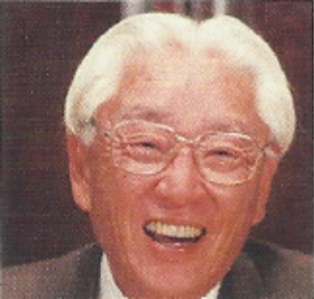 |  | Akio Morita  Akio Morita co-founded a company in Tokyo in 1946, and later changed its name to Sony. He moved to the US, where he had the original ideas for the Walkman and the video cassette recorder. Sony acquired music and film companies, and developed video games.
- Everybody makes mistakes.
- The important thing in my view is not to pin the blame for a mistake on somebody, but rather to find out what caused the mistake.
- A company will get nowhere if all of the thinking is left to management.
- Curiosity is the key to creativity.
- Executives of the company must have the necessary qualities to direct the personnel by showing them the way to do things.
- Managing is not reigning.
- Putting people down, because they lack diplomas or because they’re having trouble with a certain job, is a sign of incompetence.
- In the business world, you have exams every day.
- No theory, no plan, no system of government can assure the success of an enterprise. Only people can do that.
- [On the Sony Walkman] I just knew that this device would be a success.
- I discovered very quickly that in Western countries, employers would get rid of some personnel when a recession seemed imminent. It was a shock to me…

Jack Welch  While Jack welch was Chief Executive Officer (CEO) of General Electric in the 1980s and 1990s, its market value increased from $14 billion to more than $410 billion. He fired 10% of the company’s managers each year. |  |  | 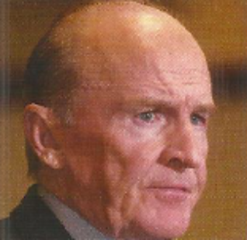
- Control Your Own Destiny or Someone Else Will.
- When you were made a leader you weren't given a crown, you were given the responsibility to bring out the best in others.
- If you pick the right people and give them the opportunity to spread their wings you almost don't have to manage them.
- It is better to act too quickly than it is to wait too long.
- Face reality as it is, not as it was or as you wish it to be.
- Life is too short to spend every day doing something you don’t love.
- Change before you have to.
- People development should be a daily event, integrated into every aspect of your regular goings-on.
- It sounds awful, but a crisis rarely ends without blood on the floor. That’s not easy or pleasant. But sadly, it is often necessary so the company can move forward again.

 | Steve Jobs  Steve Jobs was first the co-founder and later the CEO of Apple. He was fired from his own company in 1985, and co-founded Pixar Animation Studios, but rejoined Apple in 1997, and helped develop the iPod and the iPhone.
- Your work is going to fill a large part of your life, and the only way to be truly satisfied is to do what you believe is great work. And the only way to do great work is to love what you do. If you haven’t found it yet, keep looking. Don’t settle. As with all matters of the heart, you’ll know when you find it. And, like any great relationship, it just gets better and better as the years roll on. So keep looking until you find it. Don’t settle.

When I was 17, I read a quote that went something like: 'If you live each day as if it was your last, someday you'll most certainly be right.' It made an impression on me, and since then, for the past 33 years, I have looked in the mirror every morning and asked myself: ‘If today were the last day of my life, would I want to do what I am about to do today?’ And whenever the answer has been 'no' for too many days in a row, I know I need to change something.

My model for business is The Beatles. They were four guys who kept each other's kind of negative tendencies in check. They balanced each other and the total was greater than the sum of the parts. That's how I see business: Great things in business are never done by one person; they're done by a team of people.

Getting fired from Apple was the best thing that could have ever happened to me. The heaviness of being successful was replaced by the lightness of being a beginner again. It freed me to enter one of the most creative periods of my life.

Being the richest man in the cemetery doesn’t matter to me … Going to bed at night saying we’ve done something wonderful … that’s what matters to me.

Sometimes when you innovate, you make mistakes. It is best to admit them quickly, and get on with improving your other innovations.

Meg Whitman  In 1998, Meg Whitman joined a start-up company called eBay in Silicon Valley as President and CEO. She resigned ten years later, when it was a huge successful business, planning to run for Government of California. |  |  | 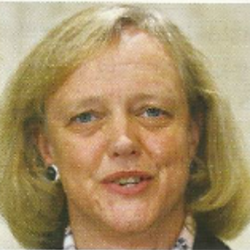
- The price of inaction is far greater than the cost of a mistake.
- Success happens when good people with good intentions cooperate and work together over a shared interest. Believing that people are basically good is what fuels most inspired individuals. Cynics and pessimists do not change the world.
- We believe people are basically good. We recognize and respect everyone as a unique individual. We believe everyone has something to contribute. We encourage people to treat others the way they want to be treated. We believe that an honest, open environment can bring out the best in people.
- We have always said that advertising is just the icing on the cake. It is not the cake.
- Communications is at the heart of e-commerce and community.

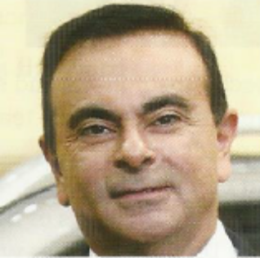 | Carlos Ghosn  Carlos Ghosn, born in Brazil, but a French and Lebanese citizen, became the CEO of the Nissan car company in 2001. In 2005, he also became CEO of Renault. At Nissan, he converted huge debts into huge profits.
- Commitment. This is my favourite word because in some way, people who are committed are always much more interesting and much more reliable, and much more, I would say, deep than people who are not.
- The role of leadership is to transform the complex situation into small pieces and prioritize them.
- Business is tough; you need tough guys.
- You'll never convince me there is a hopeless situation or there is any finality in any success or any failure.
- You don't implement change easily in Japan unless you explain very clearly why you need to do this change, how you're going to do this change and what’s going to be the outcome of this change. If you forget to explain one of these three steps you’re not going to do it.

Unit 3 Motivation
Lead-in
What kind of things motivateyou? Which of these motivators would be important for you in your choice of a job?
good working conditions / good salary / good working relations with your manager and colleagues / the possibility of promotion / a challenging job / responsibility / opportunities to travel / long holidays
What other important motivators would you add to this list?

1. Read the text about Theory X and Theory Y.
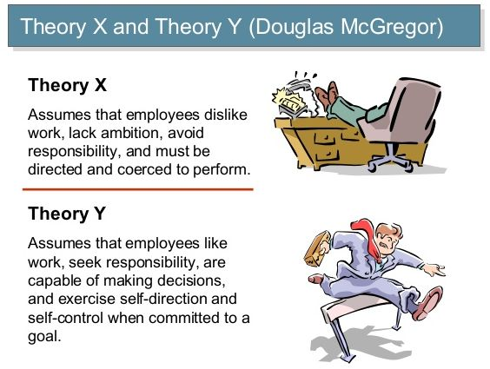
In The Human Side of Enterprise, Douglas McGregor outlined two opposing theories of work and motivation.
What he calls Theory X is the rather pessimistic approach to workers and working which assumes that people are lazy and will avoid work and responsibility if they can. Consequently, workers have to be closely supervised and controlled, and told what to do. They have to be both threatened, for example with losing their job, and rewarded with incentives, probably monetary ones such as a pay rise or bonuses.
Theory X assumes that most people are incapable of taking responsibility for themselves and have to be looked after. It has traditionally been applied, for example, by managers of factory workers in large-scale manufacturing.
Theory Y, on the contrary, assumes that most people have a psychological need to work, and given the right conditions – job security, financial rewards – they will be creative, ambitious and self-motivated by the satisfaction of doing a good job.
Theory Y is probably more applicable to skilled professionals and what Peter Drucker called ‘knowledge workers’ – managers, specialists, programmers, scientists, engineers – than people in unskilled jobs. McGregor's two theories are based on Abraham Maslow’s famous ‘hierarchy of needs’. Theory X relates to the basic, lower order needs at the bottom of the hierarchy, such as financial security, while Theory Y relates to 'higher order needs such as esteem (achievement, status and responsibility) and self-actualization (personal growth and fulfilment) that can be pursued if basic needs are satisfied.
McGregor is widely considered to have laid the foundations for the modern people-centred view of management. However, Maslow spent a year studying a Californian company that used Theory Y, and concluded that there are many people who are not looking for responsibility and achievement at work. There will always be people with little self-discipline, who need security and certainty and protection against the burden of responsibility, so it is impossible to simply replace the ‘authoritarian’ Theory X with the ‘progressive’ Theory Y.

2. Are these sentences true or false?
1. Theory X is a more traditional description of relationship between managers and employees.
2. Theory Y is common in hierarchical top-down organizations.
3. Theory Y managers tell workers what to do.
4. Theory X managers are authoritarian.
5. Theory Y employees are lazy and don’t want to work.
6. For theory X workers, work is natural.
7. Theory Y working relations are open, communicative and creative.

3. Put the following words and phrases below into the correct column:
communication control cooperation creativity direction modern orders participation security traditional work is necessity work is natural

Theory X | Theory Y

4. Match up the following words and definitions.
1 approach | Aa thing that motivates or encourages someone to do something
2 responsibility | B cause someone to be vulnerable or at risk
3 incentive | C the state of feeling safe, stable, and free from fear or anxiety
4 supervise | D a way of dealing with a situation or problem
5 threaten | E a thing done successfully with effort, skill, or courage
6 achievement | F having or showing the knowledge, ability to perform a certain activity or task well
7 security | G the opportunity or ability to act independently and take decisions without authorization
8 skilled | H observe and direct the work of someone

5. Summarise the main ideas of Theory X and Theory Y.

6. Read the text about‘satisfiers’ and ‘motivators’.Why are good working conditions not sufficient to motivate employees?
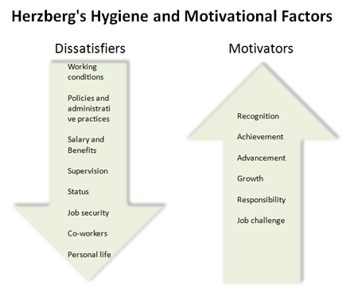
It is logical to suppose that things like good labour relations, good working conditions, job security, good wages, and benefits such as sick pay, paid holidays and a pension are incentives that motivate workers. But in The Motivation to Work, Frederick Herzberg argued that such conditions – or ‘hygiene factors’ – do not in fact motivate workers. They are merely ‘satisfiers’ – or, more importantly, ‘dissatisfiers’ where they do not exist. Workers who have them take them for granted. As Herzberg put it, ‘A reward once given becomes a right.’‘Motivators’, on the contrary, include things such as having a challenging and interesting job, recognition and responsibility, promotion, and so on. Unless people are motivated, and want to do a good job, they will not perform well.
However, there are and always will be plenty of boring, repetitive and mechanical jobs, and lots of unskilled workers who have to do them. How can managers motivate people in such jobs? One solution is to give them some responsibilities, not as individuals but as part of a team. For example, some supermarkets combine office staff, the people who fill the shelves, and the people who work on the checkout tills into a team and let them decide what product lines to stock, how to display them, and so on. Other employers encourage job rotation, as doing four different repetitive jobs a day is better than doing only one. Many people now talk about the importance of a company’s shared values or corporate culture, with which all the staff can identify: for example being the best hotel chain, or hamburger restaurant chain, or airline, or making the best, safest, most user-friendly, most ecological or most reliable products in a particular field. Unfortunately, not all the competing companies in an industry can seriously claim to be the best.

7. Are these sentences true or false?
1. Herzberg argued that ‘hygiene factors’ motivate workers.
2. Challenging jobs and responsibility are hygiene factors.
3. Some unskilled jobs will always be boring and repetitive.
4. Workers might be motivated by having responsibilities as part of a team.
5. Job rotation can make a day’s work more interesting.
6. You can always motivate workers by telling them that they work for the best company in the field.

8. Watch the videohttps://www.youtube.com/watch?v=R8TzmG-Pr40and summarize in 7-10 sentences the ideas how to motivate and inspire employees.

9. Discuss what you would do to try to motivate subordinates who did not want to take responsibilities, and who had uninteresting, repetitive jobs.

10. Case study: A car manufacturer
The senior managers of a car manufacturer sense an increasing level of dissatisfaction among most of the different categories of staff. The company has the following groups of employees, with different benefits:
- senior management (high salaries, free company cars, company restaurant, 25 days annual holiday)
- designers (high salaries, free company cars, company canteen, 20 days holiday)
- production-line workers (fixed salary, company canteen, 20 days holiday)
- secretarial and administrative staff (salary according to experience, company canteen, 20 days holiday)
- sales representatives (low fixed salary plus commission on sales, 20 days holiday)
- canteen and restaurant staff (20 days holiday, free meals in canteen)cleaners (hourly wages, plus 8.33% extra as holiday pay, no other benefits).
The managers meet to consider ways of increasing staff motivation. They have to decide whether any of the following suggestions would be appropriate for different groups of employees:
- building sports facilities (e.g. a gymnasium, tennis courts)
- establishing a profit-sharing programme
- giving longer paid holidays (such as an extra day for every year worked over ten years)
- offering cars at discount prices
- offering career training
- offering early retirement
- paying a higher salary
- paying productivity bonuses
- reducing the working week (e.g. to 35 hours)
- setting up a crèche for employees’ pre-school-age children
- spending some money on decorating the organization’s premises (e.g. with plants, pictures)
- subsidizing the staff canteen
In small groups, decide whether to implement any of these suggestions.

Unit 4 Recruitment

Lead-in
If 100 young people with very similar experience and qualifications apply for a job, which elements in a CV or resume make a difference, and might lead to a job interview?
How many times do you expect to apply for a new position during your career?
How many times do you expect to change jobs?
What does this cartoon say about the recruitment process?

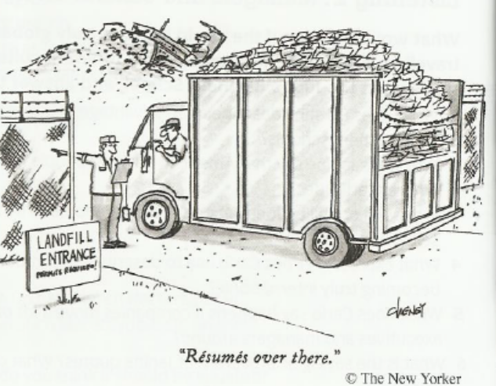

1. Explain the difference between the following pairs of words:
a) a career and a profession
b) a certificate and a qualification
c) skills and experience

2. Complete the table with the appropriate verbs.
Noun | Verb | Noun | Verb
application  dismissal  increase  interview  offer  promotion | apply for | resignation  rejection  reprimand  rise  retirement  shortlist

3. Look at the information below and put the nouns from exercise 2 and from the box in the appropriate places in the stories about Angela, Ben and Sheila.

part-time job temporary job contract pension job description
job centre redundancy Curriculum Vitae (CV) unemployment benefit (dole)

ANGELA
A1 Angela prepared a summary of her qualifications and experience.
_______________
A2 She saw an ad (advertisement) in the newspaper and wrote a letter to the Personnel Department. _______________
A3 She received a letter saying that she and a few others had been selected to meet managers on a certain day. _______________
A4 With the letter there was a list of things that the job involves______________
A5 Angela attended a formal meeting at which some managers asked questions about her experience, qualifications, etc. _______________
A6 She received a letter telling her that she had got the job. _______________
A7 There was also a formal document, telling her about working hours, holidays, salary, etc. She had to sign this. _______________

BEN
B1 Ben applied for a job. He got a letter back saying that he hadn’t got the job.
_______________
B2 After trying several times, he went to an office where they help to find jobs.
_______________
B3 They took all his details. Later they phoned him and offered him a job just for a few weeks. _______________

B4 After this job, he got another, but it only involved working for part of the day.
_____________
B5 Ben got to the age of 65, the age when employees stop working.___________
B6 Now he gets money monthly during his old age from the government and from his employers. _____________

SHEILA
C1 Sheila got on very well in her first job, and after a while she got a higher salary. _____________
C2 She did so well that after a year, she was given a new job with more responsibility. _____________
C3 After a while, the quality of her work was not good enough, and she was often late. She had to see the boss, who told her she was not satisfied. _____________
C4 Sheila’s work continued to be unsatisfactory. After another warning the boss told her that she had to leave. _____________
C5 Sheila got another job, but she didn’t like the work and decided that she wanted to leave. _____________
C6 Sheila got a third job, but after weeks the company went bankrupt and her job came to an end. _____________
C7 After several weeks without a job, she registered at a government office. They paid her a small amount of money every week. _____________

4. Put the following steps in Joe Bloggs' career in the correct order.
A He was promoted to assistant to the sales manager. ___
B He took up gardening as a hobby. 12
C He looked for a job. ___
D He was appointed managing director. ___
E He made an application. ___
F He was offered the job. ___
G He was out of work. ___
H He retired. ___
I He went for an interview. ___
J He worked as a clerk. ___
K He got the job of sales manager. ___
L He gave in his resignation. 1

5. Use the words and word combinations in the box to complete the sentences below. There is one extra word you do not have to use.

interview job description applicant application application form apply candidate CV employment agencies dole job vacancies references short-listed

Many people looking for work read the (1) … advertised in newspapers by companies and (2) … . To reply to an advertisement is to (3) … for a job. You become a (4) … or a (5) … You write an (6) …, or fill in the company’s (7) … , and send it, along with your (8) … and a covering letter. You often have to give the names of two people who are prepared to write (9) … for you. If your qualifications and abilities match the (10) … , you might be (11) … , i.e. selected to attend an (12) … .

Further tips for job interviews
Which five of these tips do you think are the most useful?
Research the company thoroughly.
Have complimentary things to say about the company and its products or services.
Be confident and enthusiastic.
Be prepared to talk about your strengths and weaknesses.
Expect questions about difficult situations you have faced, problems you have solved, etc.
Have examples of successful experiences with groups or teams.
If you talk about your hobbies, try to say something interesting and memorable (and not just ‘music, cinema, travel’).
Have some questions you can ask the interviewer, such as:
Can you tell me more about your training programmes?
Can you tell me how performance is measured and reviewed?
Are there possibilities of promotion for someone whose results are good?
Is the company facing any major challenges I don’t know about?

6. Watch the video ‘Common interview questions and answers – Job interview skills’https://www.youtube.com/watch?v=1mHjMNZZvFo&t=107sand write your own answers to 8 questions from the video.

7. Complete the text using the words/phrases from the box.

commencing salary date of commencement duties and responsibilities grievance holiday entitlement notice pension position probationary service sickness pay terms and conditions

Full-time Employment Contract
1. You have been appointed to the position of administrative assistant.
2. Your ___ will be as detailed in the attached Job Description, but this Job Description should not be regarded as exclusive or exhaustive. There will be other occasional duties and requirements associated with your appointment.
3. The ___ of your continuous service with this company is 1 January 2002.
4. Your specific ___ are contained in the Employees’ Handbook issued by the company, as well as in existing collective agreements negotiated by this company.
5. Confirmation of your appointment will be subject to your satisfactory completion of 3 months’ ___.
6. Your ___ is £20,000 per annum, paid monthly in arrears. Overtime is not payable.
7. Your ___ entitlement is 30 days in any calendar year.
8. Your annual ___ is 25 days which cannot be carried over.
9. The minimum period of ___ to which you are entitled is 3 months.
10. Your position with regard to ___ is set out in the explanatory booklet attached.
11. If you have a ___ relating to your employment, you should refer to the complaints procedure outlined in the booklet attached.

8. Below is a letter of redundancy. The sentences have been mixed up. Put them into order.
Letter of redundancy
1 Details of your forthcoming redundancy and severance pay are enclosed.
2 Finally I shall, of course, be only too pleased to supply any prospective employer with a reference on your behalf.
3 I am writing in connection with our discussion of earlier today.
4 Yours sincerely Anne O’Dwyer, Personnel Manager
5 It is with much regret that I must ask you to accept this letter as formal notice of the redundancy of your position as administrative assistant with effect from 30 September 2010.
6 Dear Ms Bailey
7 On behalf of the Company, I would like to thank you for the services you have given us in the past and wish you every success in the future.
8 Please do not hesitate to contact me if you need clarification.
9 The Company will gladly grant you reasonable time off with pay for the purposes of attending job interviews or undertaking any training for alternative employment.
10 The services of the Personnel Department will, of course, be freely available to assist you in obtaining suitable alternative employment.

6

9. Discussion: CVs/resumes and covering letters
Why is it normal in some countries not to include photos or personal details on a CV/resume?
Should a CV really be totally honest? Do you think most people are completely honest?
Why might an employer want to know about your hobbies and interests?
Would you want to work for someone who might be prejudiced against your country of origin or religion?
Would you target each covering letter if you were applying to 30 companies?

10. Case study: Selecting a Chief Operating Officer
Three companies are looking for a senior manager – a Chief Operating Officer who will be responsible for managing the company’s day-to-day operations, and making sure that all operations are efficient and effective.
Company A is a cigarette manufacturer that has to modernize its production systems in order to become profitable, in an industry that has an increasingly bad reputation.
Company B is a software developer that employs a lot of young, creative, talented and rather undisciplined people.
Company C is a private television channel whose objective is to broadcast programmes that get as big an audience as possible, in order to maximize advertising revenue.

Which of the following candidates might be the most suitable for the positions?
Candidate 1. My skills involve helping businesses achieve their objectives. Throughout my career I have ensured that my subordinates successfully executed the strategies developed by senior management, delivered results and maximized revenue.
Candidate 2. I see my main skills as being able to communicate with and motivate people, to help them develop and accomplish their objectives, while also working effectively in teams.
Candidate 3. At this stage in my career, I see myself in a challenging new position that involves setting objectives and deciding how the organization can achieve them. I would then concentrate on measuring the performance of the staff.
Candidate 4. My career demonstrates an ability to analyse problems, find solutions and implement them. I also have strong communication skills and experience in explaining difficult decisions to employees, investors, journalists, and so on.

Curriculum vitae (CV) Useful tips

1 Use wide margins and leave lots of white space. It makes your CV easier to read.
2 Use a clear, easy-to-read typeface. Don't use italics or a small type size. Be consistent with the typefaces you use.
3 Make the section headings clear and leave a clear space between sections.
4 Separate each part of your work experience and education clearly.
5 Don't assume the reader will know what some abbreviations and acronyms mean. If in doubt, use the full name.
6 Don’t exaggerate your talents but don't underestimate them either. Remember to sell yourself by using positive adjectives.
7 Watch out for grammar and spelling mistakes. Do a spell and grammar check on your computer when you finish your CV and ask someone else to check it for you.

Social skills and competences | Social skills and competences refer to living and working with other people, in positions where communication is important and situations where teamwork is essential (for example culture and sports), in multicultural environments, etc.  Describe your social skills and competences, e.g.:  - - team spirit;  - - good ability to adapt to multicultural environments, gained though my work experience abroad;  - - good communication skills gained through my experience as sales manager.  Specify in what context they were acquired (through training, work, seminars, voluntary or leisure activities, etc.).
Organisational skills  and competences | Organisational skills and competences refer to coordination and administration of people, projects and budgets; at work, in voluntary work (for example culture and sports) and at home, etc.  Describe your organisational skills and competences, e.g.:  - - leadership (currently responsible for a team of 10 people);  - - sense of organisation (experience in logistics);  - - good experience in project or team management.  and say in what context they were acquired (through training, work, seminars, voluntary or leisure activities, etc.).
Computer skills and competences | Computer skills and competences refer to word processing and other applications, database searching, acquaintance with Internet, advanced skills (programming etc.). Describe your computer skills and competences, e.g.:  - - good command of Microsoft Office™ tools (Word™, Excel™ and PowerPoint™);  - - basic knowledge of graphic design applications (Adobe Illustrator™, PhotoShop™).  Specify in what context they were acquired (through training, work, seminar, voluntary or leisure activities, etc.).
Artistic skills and competences | State here your artistic skills and competences which are an asset (music; writing; design, etc.) e.g.:  carpentry  Specify in what context they were acquired (through training, work, seminars, voluntary or leisure activities, etc.).
Other skills  and  competences | State here any other skill(s) and competence(s) which are an asset and are not mentioned under earlier headings (hobbies; sports, positions of responsibility in voluntary organisations), e.g.:  trekking  Specify in what context they were acquired (through training, work, voluntary or leisure activities, etc.).
Driving  licence(s) | State here whether you hold a driving licence and, if so, for which category of vehicle, e.g.:  Category B

11. Study the CV example and write your CV.

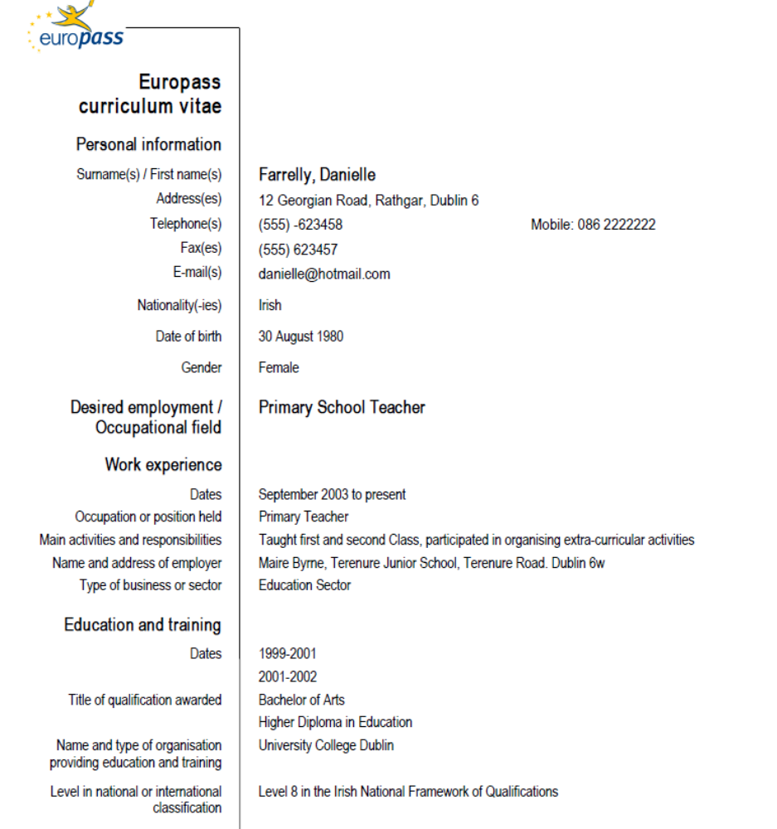
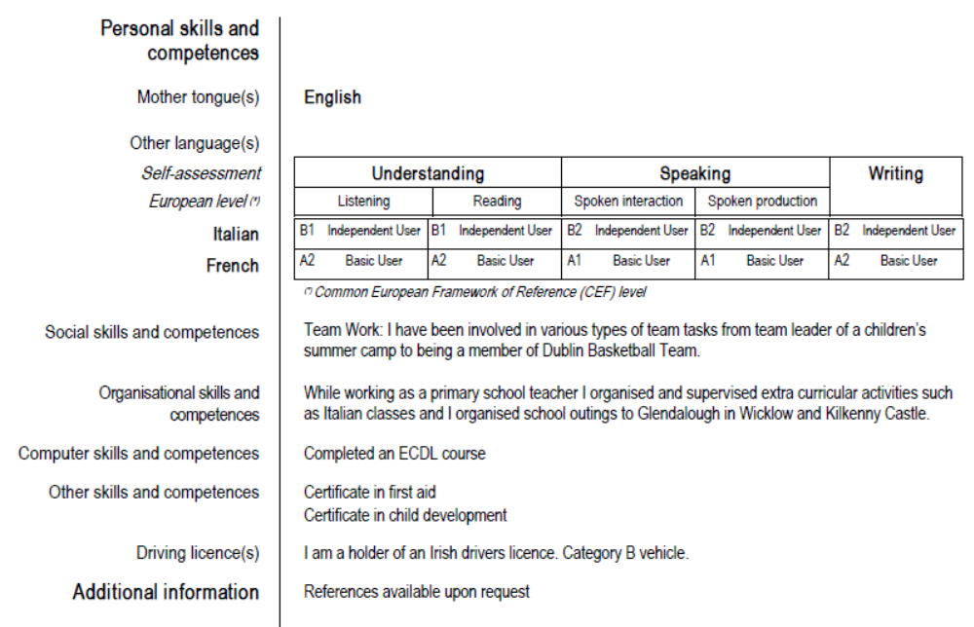

Unit 5 Managing across cultures

Lead-in
Consider the importance of cultural differences for people working across cultures.
Discuss the conflict between globalization and localization.
What are the advantages and disadvantages of a multinational company adapting its management methods to the local culture in each country in which it operates?
To what extent is the culture of your country similar enough to those of neighbouring countries to have the same management techniques? Or do they have very different attitudes to work, hierarchy, organization, and so on? If so, what are these differences?
In your country, what gains respect within an organization, long service or achievement?
Can a young, dynamic, aggressive manager with an MBA rise quickly in the hierarchy?

1. Read the text about Richard Lewis’ model of three types of cultures.
Richard Lewis is well known in the field of cross-cultural communication and the author of When Cultures Collide: Managing Successfully Across Cultures and The Cultural Imperative: Global Trends in the 21st Century. | 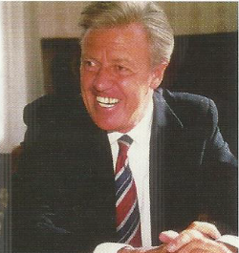

Managing a global multinational company would obviously be much simpler if it required only one set of corporate objectives, goals, policies, practices, products and services. But local differences - cultural habits, beliefs andprinciples specific to each country or market - often make this impossible.
The conflict between globalization and localization has led to the invention of the word 'localization'. Companies that want to be successful in foreign markets have to be aware of the local cultural characteristics that affect the way business is done.
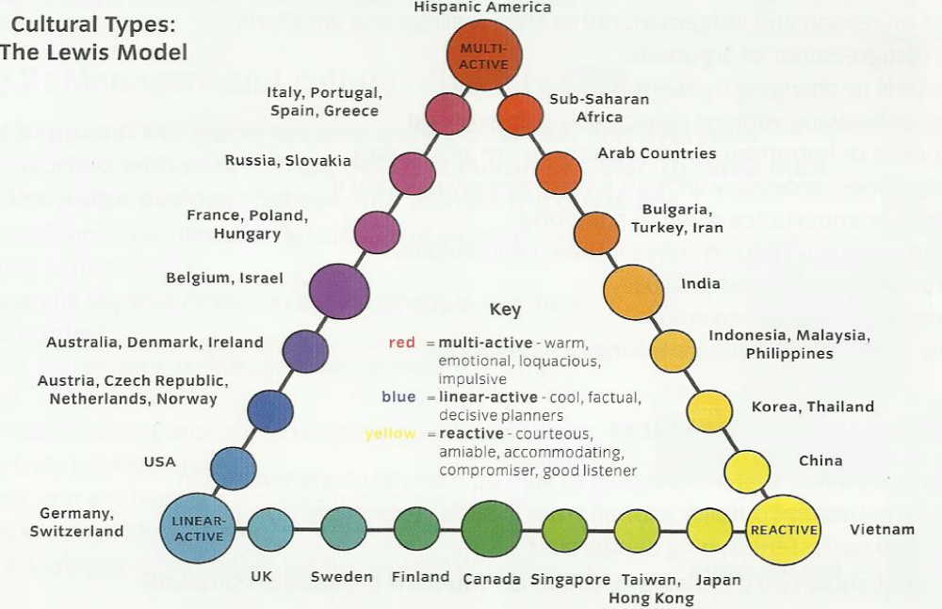
Richard Lewis has classified different cultures according to three 'poles' representing different types of behaviour. Business people in 'linear-active' cultures such as Britain, the USA and Germany are generally organized and rational, try to act logically rather than emotionally, plan in advance, and like to do one thing at a time. They believe in respecting rules, regulations and contracts, and so are what the Dutch theorist FonsTrompenaars calls 'universalists' - they think rules apply to everybody. They are not afraid of confrontation but will compromise when necessary to achieve a deal. They are essentially individualist.
'Multi-active cultures' in Southern Europe, Latin America and Africa attach more importance to feelings, emotions and intuition, and relationships and connections. People like to do many things at the same time; they are flexible, good at changing plans and happy to improvise. They believe in social or company hierarchy, and respect status. They are essentially collectivist, and also what Trompenaars calls 'particularist' - they believe that personal relationships and friendships should take precedence over rules and regulations.
People in 'reactive cultures' in Asia prefer to listen to and establish the other's position, and then react to it. They try to avoid confrontation, and don't want to 'lose face' or cause someone else to. They rarely interrupt speakers and often avoid eye contact. They try to formulate approaches which suit both parties.
Other countries have cultures which show combined characteristics of two of these poles, and can be represented along the sides of a triangle.

2. Answer the following questions.
- Why is it important for companies to be aware of local cultures?
- What are the differences between individualists and collectivists?
- Who is more likely to think: I'll let them speak first.’
- Who is more likely to say, about other people: ‘They can’t be trusted because they will always help their friends or family’ - universalists or particularists?
- Who is more likely to say: 'Oh, you can't trust them; they wouldn't even help a friend’?

3. Match the words in the box with the definitions.
collectivist | an invented word combining worldwide and regional concerns
compromise | thought based on reason and judgement rather than feelings and emotions
confrontation | reducing demands or changing opinions in order to agree
connections | a face-to-face disagreement or argument
eye contact | respect, prestige or importance given to someone
glocalization | to be humiliated or disrespected in public
improvise | to cut into someone else’s turn to speak
interrupt | believing that the group is more important than the individual
intuition | to do something when necessary without having already planned it
logic | looking directly at the people you are talking or listening to
status | people of influence or importance with whom you are associated
lose face | understanding or knowing without consciously using reason

4. Discuss with your partner or in groups:
- To what extent do you agree that it is possible to sum up national characteristics in a few words? Is there usually some (or a lot of) truth in such stereotypes? Or, on the contrary, do you find such stereotyping dangerous?
- If your country is not shown on the diagram, where do you think it should be situated?
- If your country is shown, do you agree?
- Would you say that you, personally, were individualist or collectivist? Particularist or universalist?
- What about the majority of people in your country?
- Which of the following working practices would be effective or damaging in your country? Why?
- the principle of ‘pay-for-performance’ for sales representatives - the more they sell, the more they get paid
- having a competition for the ‘Employee of the month'
- having a matrix management system
- extensive teamwork

5. Write a short text (100-150 words) explaining which five of the factors listed below you think have had the most influence on your behaviour and attitudes. Put them in order of priority.
- Nature: your genes or DNA, the characteristics you inherited from your parents and were born with, your emotional and physical make-up
- Your family environment in early life
- Your friends and social life, the things you do in your free time
- Primary or secondary school, teachers, and what you learnt
- Higher education: college, university, teachers, colleagues, the subjects you studied (or are studying)
- Your job
- The culture of your particular company
- Your colleagues: the people in your team or department
- Your colleagues: the kind of people who work in of your specific area of work
- The characteristics that are considered typical of your country, arising from geography, climate, history, religion, the political, social and economic system, and so on
6. In groups, report on your choices and explain them.

7. Role play.Welcoming American colleagues
You work in a multinational organization. You have been given the responsibility of mentoring two American colleagues who are coming to work in your office. You have been asked to help them settle in to their new workplace by preparing a short document outlining the general practices they can expect to find when they are living and working in your country.
The document could include information about working practices in your office, as well as practical information about your city or country, including advice about transport, and conventions such as tipping in taxis and restaurants.
In groups discuss what should go in this document and then present these ideas to the rest of the class.

8. Discuss with your partner why cultural awareness is important for people. Give examples. Choose the four factors which you think are the most important in creating a culture.
climate | language | historical events
institutions | arts | social customs and traditions
ideas and beliefs | religion | ceremonies and festivals
cuisine | geography | architecture

9. Do you think cultures are becoming more alike? Is this a good thing or a bad thing? Give reasons for your answers. Think about:
- improved communications
- cheap foreign travel
- global business
- trading groups (such as the EU, ASEAN)

10. How important are the following things when doing business in your country? Are they important, not important or best avoided?

exchanging business cards | being formal or informal
shaking hands | punctuality
kissing | humour
socialising with contacts | giving presents
small talk before meetings | being direct (saying exactly what you think)
accepting interruption | using first names

11. Read the articles about doing business in different countries and answer the questions after text.
A: Italy
Conversation
Lively conversation is common in Italy. Welcome topics of conversation include Italian architecture, art and films, sports (especially football), opera and praising the hospitality of the country! It is best to avoid criticising Italian culture, even if your Italian counterparts are doing so.
Gift-giving
Don’t give a business gift until you receive one. Your gift should be a well-known brand name. gifts of alcohol or crafts from your own country are often good choices. Other possible gifts are fine pens, a framed print or picture, silver key rings or calculators. Avoid giving gifts showing your company’s logo.
Entertaining
Hospitality plays a key role in Italian business culture. Regardless of how you feel, refusing an invitation of any kind may give offence. The business breakfast is almost unheard of. Rare exceptions may be found in the major cities. Business dinners involve only a small, exclusive group. If you are the host, check with your Italian contact before making any invitations. Lunch is still the main meal of the day in most areas of the country. It is usually served after 12:30 p.m. and often has many courses.

B: United Arab Emirates
Conversation
The hosts usually set the subject of conversation. They will normally begin with polite enquiries (How are you? How are you enjoying your visit? etc.). If others arrived before you, your hosts will often tell you the subject of the previous convesation and invite you to contribute.
Gift-giving
Giving gifts in the UAE is more complex than in other countries. This is partly because of the mixture of nationalities: each nationality has different tastes and customs. Also, nearly everything can be purchased in the UAE less expensively than elsewhere in the world. As a gesture of respect, your host is likely to open and carefully examine your gift in your presence. It is important that your gift is the best you can afford to avoid embarrassment.
Entertaining
Sharing a meal is considered the best way for people to get to know one another. Locals often entertain at home but they will accept a foreigner’s invitation to a hotel or restaurant. Hospitality in the UAE is very important but should not be interpreted as future commercial success. There are local customs to be aware of, for example, it is considered bad manners to either eat or offer something with the left hand.

C: South Korea
Conversation
You may be asked personal questions about your age, salary, education, religion, and family life. If you don’t want to answer, remain polite but try to politely avoid answering. In most cases, people ask in order to esablish a rapport by finding common ground.
Gift-giving
Giving gifts is a common practice in the workplae, and the receiver is expected to give a gift in return. Good gifts for a first trip include office items with your company logo or something produced in your country. Your gift should be of good quality ut modestly priced. When you plan to give a gift to several people within an organisation, be sure to give a gift of greater value to the senior person.
Entertainment
Drinking is an important part of doing business. It is common to be invited out in the evening to a restaurant/bar where there will be a lt of alcohol. Towards the end of an evening the most hounoured person will be asked to sing solo. Make sure that you know one very simple song and do your best. Refusing to sing is considered bad manners.

D: Brazil
Conversation
Conversations tend to be fast and lively. You may sometimes be asked personal qustions about your income, religion, and marital status.if you don’t want to reveal this information, remain polite but give a vague reply.
Gift-giving
Giving a gift is not neessary during a first meeting. Instead, offer to buy lunch or dinner and use this oportunity to learn more about your guest’s tastes. This way, later on when gifts are exchanged, you’ll be able to give an appropriate gift. Do not give anything that is obvious expensive. Your generosity may cause embarassement or be misinterpreted. Small electronic items are often appreciated. Good choices include scientific calculators, electronic address books and pocket CD players, etc.
Entertainment
Business entertaining is conducted over lunch or dinner. You are expected to arrive on time. It is business etiquette in Brazil to shake hands with everyone in your company, both upon arrival and upon departure. It’s unusual to touch food with your fingers. Cut all food, including fruit and sandwiches, with your knife.

In which country or countries:
- do people talk in a lively way?
- do people ask questions about your personal life?
- does the host invite you to comment on a previous conversation?
- do the hosts like to hear praise about their country?
- do people like gifts with your company logo?
- is it important to give a more expensive gift to the most senior person?
- does your host open your gift immediately?
- is it a mistake to offer an expensive gift?
- is it bad manners to refuse an invitation to a meal?
- is it rude to refuse to sing when asked?
- is it important to be punctual for lunch or dinner?
- is it important not to offer food with your left hand?

12.What advice would you give a visitor to your country? Give a short presentation. You could mention conversation, gifts, entertainment, appointments and business dress.

Unit 6 Team Building

Lead in
Think at least two advantages and disadvantages of working in teams.
For each category in the quiz below, tick the three statements that most apply to you. Then read the explanations.

What sort of team player are you?

Doers vs Thinkers | Details vs Ideas | Mind vs Heart | Planners vs Improvisers
- I consider what I say.  - I contribute a lot in discussions.  - Action is more important than reflection.  - I listen to others before I say anything.  - Discussion gives me energy and ideas.  - I don’t say a lot at meetings. | - I often come up with unusual solutions.  - It’s important to be realistic.  - People see me as a creative person.  - I like practical solutions.  - You shouldn’t overlook details.  - You shouldn’t get lost in details. | - I like to think logically.  - I keep emotions out of decision-making.  - I avoid confrontation.  - I sometimes tread on people’s toes.  - Understanding people is as important as being right.  - I care about other people’s feelings. | - Meetings have to be prepared for carefully.  - I like surprises.  - I hate time-wasting at meetings.  - Too much time can be spent on preparation.  - People say I’m a punctual person.  - I need a deadline to get me going.

Score 1 point for each of the following answers:
Doers vs Thinkers: a), d), f)
Mind vs Heart: a), b), d)
Details vs Ideas: b), d), e)
Planners vs Improvisers: a), c), e)

Score 2 points for each of the following answers:
Doers vs Thinkers: b), c), e)
Mind vs Heart: c), e), f)
Details vs Ideas: a), c), f)
Planners vs Improvisers: b), d), f)

18-24 points:
You are definitely a creative type. You value original ideas over detailed planning. You are likely to show consideration for others. You can get bored easily and sometimes need to be under pressure to get results.

12-17 points:
Clear thinking and careful planning are of great importance to you. You are not afraid of challenging others in order to get results. You are likely to be ambitious and well organized.

Work in groups and compare your answers. Then discuss these questions:
- How important are thinking styles in effective teamwork?
- Do you think your group would make a good team, based on the results of the quiz? Explain why or why not.

1. Match prefixes of the words 1-10 to their meanings.
Prefix |  | Meaning of prefix
1 | mismanage | a | not | b | do badly | c | former
2 | pro-European | a | opposite | b | in favour of | c | before
3 | predict | a | not enough | b | against | c | before
4 | post-merger | a | after | b | too much | c | not enough
5 | dishonest | a | very | b | former | c | not
6 | ex-boss | a | opposite | b | former | c | after
7 | bilateral | a | against | b | after | c | two
8 | reconsider | a | again | b | former | c | after
9 | irresponsible | a | again | b | not | c | against
10 | hypercritical | a | not enough | b | very | c | opposite

2. Complete the text below using some of the words in Exercise 1 in the correct form.
Our company went through a difficult period a few years ago. Bad decisions were taken which caused us to lose a lot of money. Because the company had been ______1, the chief executive had to resign. Last year, we merged with a much larger company. During the ______2 period our future strategy was discussed. It was decided that we could consider becoming a more global organization with a strong presence in Europe.
Most of us were ______3, we liked the idea of expanding into Europe. Indeed our ______4 had been strongly in favour of doing this. However the two new board members were strongly against the idea but never said so openly. I think this was very ______5. Instead, they behaved in an ______6 manner during meetings. For example, they would be ______7, raising stupid objections if someone came up with a good idea.
Because the meetings were so unproductive, the Board of Directors got cold feet and asked us to ______8 the decision to expand into Europe.

3. Add prefixes to the words to give their opposite meanings. Then use them to discuss the questions that follow.
Communicative, decisive, efficient, enthusiastic, flexible, focused, imaginative, loyal, organised, practical, sociable, sable, tolerant.
- Who is the best or worst person you have ever worked with? Explain why.
- What qualities could you contribute to a team? What qualities would the other members need to have to create an effective team?

4. Read the article and answer these questions.
- What is the difference between the past and the present in terms of the key to success in a career?
- What does the writer say about competition in the first paragraph?
- In the second paragraph what does the writer say you need to be a good team player?
- What three points does the writer make about effective teams in the third paragraph?
- According to the writer which of the following attitudes should team members have?
- We know exactly what we are trying to achieve.
- I will lead when necessary.
- People value my work.
- I speak when invited by the team leader.
- I am encouraged to be very critical of colleagues’ opinions.
- Why does the writer think that cultural differences do not have a big influence on teams?
- What is the difference between Thai and Western team members?
- None of us is as smart as all of us. Do you agree? In what situations is it true or not true? Give examples.

None of us is as smart as all of us
By Howard Cant
A good team player has the key to success. Being the smartest, being the rightest, being the hardest; all of these attributes that worked so well in business in years gone by, now will not push you up the ladder quickly. How good a team player you are and how well you share your knowledge with your colleagues is the all-important factor in growing your career today. If you can build a company culture that does not worry about who gets credit for something, think about what you could achieve! To survive in the big bad tough working environment of today you don’t need to have your own competing with each other. It is the commercial “enemy” against whom all their energy should be focused.
It’s not always easy to be a good team member and compromise your own views for the good of the whole, but it works for the betterment of the company. You have to believe in the workings and power of the team and recognize where your own strengths and contribution fit in. You have to be honest, both with yourself and with your team members. You will conflict within the team and as long as this is controlled then it can be a very healthy element for both team and the development of the business. Research into high-performing teams shows that each member cares for the development of his team mates. This appreciation of each other’s learning and development is key to success of a team and the commitment of each member to the other.
Over 70% of a manager’s time is spent in some form of group activity, often in meetings with others; relatively little time is spent in the supervising of single individuals or on one-to-one discussions, thus the need for team building. Indeed, the success of individual managers depends on how well that manager’s team or teams improve in quality and productivity on a continuous basis. In reality, group productivity is more important than individual task accomplishment. The most effective teams are able to solve complex problems more easily than one person can, for many capable minds are brought to bear on an issue. However, all teams must be managed well by a capable facilitator who understands that every team is unique, dynamic and ever-changing. Moreover, teams have behavior patterns, just as individuals do and, just as children develop into adults, teams have developmental stages, being more productive and efficient at one stage than another.
It is also extremely desirable for team members to have the following attitudes; “I know what I have to do and the team’s goals are clear”, “I am willing to share some responsibility for leadership”, “I am an active participant”, “I feel appreciated and supported by others”, “Other team members listen when I speak and respect the opinions of others”, “Communication is open, new ideas are encouraged and we are having fun working together”.
Teams soon develop a clear problem-solving approach that can be applied time and again as long as their leader initially creates a common purpose and vision, pointing the team in the right direction.
Cross-cultural issues can assail and impact the working of teams, but it is well to remember that, despite culture, most team members have similar objectives in life. Objectives that relate to happiness and health, to success and recognition, to love and being well-accepted by others. The clever team leader recognises and plays upon these similarities while moulding the cultural differences to benefit the team. For example, Thai team members place a greater focus on personal relationships in everything they do while Western team members are looking more for personal achievement.

5. Complete the missing letters in the following words. Which of these qualities do you possess that would be useful when working in a team?

- p_t__nc_  - f_r_s_ght  - cr_ _t_v_ty  - _rg_nis_t_ _n  - _nt_ _t_ _n | - t_ _ghn_ss  - st_m_n_  - d_pl_m_cy  - h_n_sty

6. Discuss these questions.
- Do you have any other qualities which would be useful for a team?
- What would you find difficult about working in a team?
- If you were a team leader, how would you get your team members to co-operate?

7. Watch the video ‘Emotional intelligence: how good leaders become great” https://www.youtube.com/watch?v=HA15YZlF_kM and discuss how good managers use emotional intelligence to their advantage.

Unit 7 Crisis management

Lead-in
What is the difference between a problem and a crisis? When, in your opinion, does a business problem become a crisis? What do you associate crisis with? Can you give some examples of crisis situations?Say what happened and how it was handled.
 | When written in Chinese, the world crisis is compounded of two characters – one represents danger, and the other represents opportunity.

What does it mean to say that a crisis can be an opportunity? Is every crisis an opportunity?

1. Read for information. Then, explain the words in bold.
A crisis is defined as a significant threat to operations that can have negative consequences if not handled properly. In crisis management, the threat is the potential damage a crisis can inflict on an organization, its stakeholders, and an industry. A crisis can create three related threats: (1) public safety, (2) financial loss, and (3) reputation loss. Some crises, such as industrial accidents and product harm, can result in injuries and even loss of lives. Injuries or deaths will result in financial and reputation loss while reputations have a financial impact on organizations.
Crisis management is the process by which an organization deals with a disruptive and unexpected event that threatens to harm the organization, its stakeholders, or the general public.
Three elements are common to a crisis: (a) a threat to the organization, (b) the element of surprise, and (c) a short decision time. The fourth defining quality is the need for change. If change is not needed, the event could more accurately be described as a failure or incident.
In contrast to risk management, which involves assessing potential threats and finding the best ways to avoid those threats, crisis management involves dealing with threats before, during, and after they have occurred. It is a discipline within the broader context of management consisting of skills and techniques required to identify, assess, understand, and cope with a serious situation, especially from the moment it first occurs to the point that recovery procedures start.
Effective crisis management handles the threats sequentially. The primary concern in a crisis has to be public safety. A failure to address public safety intensifies the damage from a crisis. Reputation and financial concerns are considered after public safety has been remedied. Ultimately, crisis management is designed to protect an organization and its stakeholders from threats and/or reduce the impact felt by threats.
Crisis-management methods of a business or an organization are called a crisis-management plan.
A crisis mindset requires the ability to think of the worst-case scenario while simultaneously suggesting numerous solutions.
The credibility and reputation of organizations is heavily influenced by the perception of their responses during crisis situations. The organization and communication involved in responding to a crisis in a timely fashion makes for a challenge in businesses. There must be open and consistent communication throughout the hierarchy to contribute to a successful crisis-communication process.
As a process, crisis management is not just one thing. Crisis management can be divided into three phases: (1) pre-crisis, (2) crisis response, and (3) post-crisis. The pre-crisis phase is concerned with prevention and preparation. The crisis response phase is when management must actually respond to a crisis. The post-crisis phase looks for ways to better prepare for the next crisis and fulfills commitments made during the crisis phase.

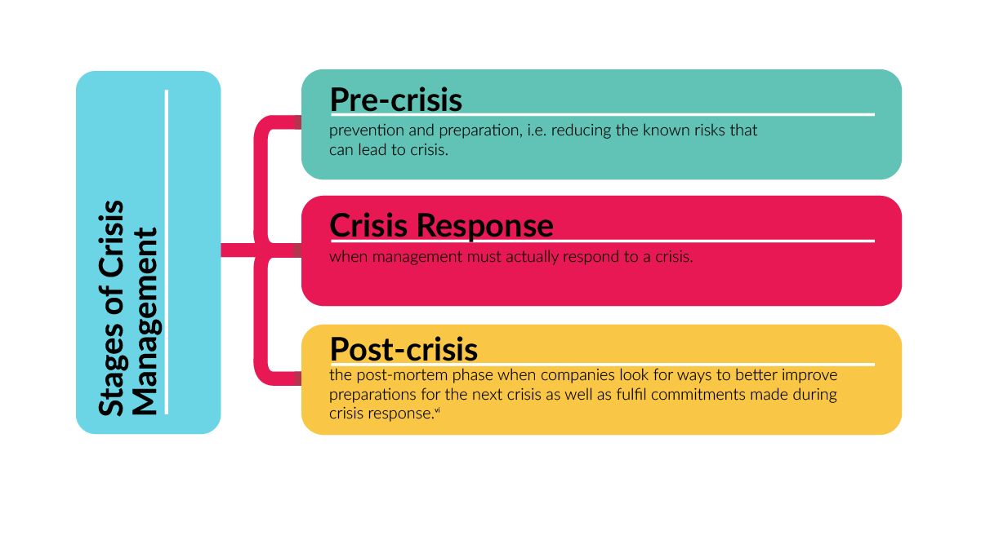
2. Use the following key steps for companies in a crisis to complete the chart below.
1. Set up a crisis management team.
2. Try to predict what crises could occur.
3. Role play a potential crisis.
4. Inform the directors.
5. Disclose as much information as you can.
6. Analyse the actions you took to deal with the situation.
7. Write down and circulate your crisis management programme.
8. Practise making decisions under stress.
9. Work out an action plan to ensure the crises does not happen again.
10. Find out what happened and how it happened.

Before the crisis | During the crisis | After the crisis

3.Imagine you are going for a holiday on a ship around the world.
What problems could arise?
Read the article and answer these questions.
1 What went wrong with the ship?
2 How did the passengers feel and why?
3 What can happen if you do not deal effectively with a service failure?
4 What interesting statistic highlights the consequences of poor service?
5 What are the four basic principles you must consider when dealing with a crisis?
6 What do P&O and Thomas Cook have in common?
7 What is the surprising fact in the last paragraph?

Keeping your client relationship afloat
by Morgan Witzel
The passengers of the Aurora had every right to be angry. The round-the-world cruise for which they had paid thousands of pounds was cancelled after persistent engine problems.
Yet there was little anger among the passengers. While the ship was held off the south coast of England, the passengers remained calm and even cheerful. Though many expressed regret as they finally disembarked, they were not hostile towards the ship’s operators, P&O. This may have been due to the 20 company’s management of the crisis.
Dealing with a service failure is a formidable task for any marketing manager. If poorly handled, the consequences can be bad public relations, desertion by customers and even lawsuits. The Aurora story shows how managers, if they move quickly, can avoid some of the worst effects of service failures.
While high-profile cases are still relatively rare, companies everywhere may regularly suffer small service failures. Plumbers fail to fix leaking drains, restaurant meals are often undercooked or holidaymakers find their hotel room is directly above an all-night disco. Every failure is bound to create a dissatisfied customer, which in turn creates other problems for the company.
Unhappy customers tend to tell others of their experience. Studiesin the US have shown that dissatisfied customers tend to tell around ten other people of their bad experience; even worse, they can take their stories to the press.
Dissatisfied customers also defect to rival businesses. Although every service failure will be different, some basic principles can assist in recovery. The first is early recognition of the problem, In P&O’s case this was easy: everyone involved knew that the large ship was not going anywhere. Other failures are harder to detect, especially when management is asleep at the wheel.
The second principle is accepting responsibility. Many companies prefer to argue with customers over where responsibility lies, so without realising that damage is being done regardless of who is at fault. Although there are limits to the responsibilities companies should accept – such as accidents and injuries that were not the company’s fault – there is usually little profit in scoring moral victories over customers. Hence clothing retailers often have a no-questions-asked policy on returned goods, believing that the harm done by the occasional dishonest customer is more than outweighed by the satisfaction created among the rest.
Once responsibility is accepted, the two most urgent needs for the company to address are communication and compensation. Transparency is vital. Academic studies have shown that when faced with product or service failure, companies that communicate truthfully and promptly with their customers receive a favourable response. These customers feel that their concerns are actually being addressed and taken no seriously. In the Aurora case, senior P&O managers were often on hand to provide information to passengers, who regarded this as a positive feature.
Compensation must he carefully matched to the customer’s dissatisfaction. Too small an amount trivialises the customer’s experience and can give offence, but it is also possible to go too far the other way. Researchers in the US found an example of a hotel chain that had a policy of instantly refunding the full room rate to any guest with a genuine complaint, no matter how trivial. Yet many customers – against expectations – found it embarrassing to be given hundreds of dollars in compensation when they had merely complained about a faulty light fixture or a dripping tap.
Service industries often have their compensation benchmarks. In the holiday sector, the standard was set by the 19th-century inventor of the package holiday, Thomas Cook, who made it his policy to refund in full the money paid by any customer whose holiday was curtailed or cancelled, and offer a discount on their next booking. P&O’s policy would have pleased Cook – the company reportedly offered the same level of compensation to the passengers of the Aurora. Not every package holiday company follows this example.
Following these simple principles should please most customers most of the time. Research across a wide variety of service industries over the past 20 years confirms that a successful service recovery operation reduces or even eliminates any consumer dissatisfaction.
The aborted cruise of the Aurora was disappointing for P&O passengers. But the consequences could have been far worse. Many of the passengers said they planned to travel on a P&O 190 cruise in the future.
From the Financial Times

4. The writer provides guidelines for dealing with a crisis. Read the article again and complete the guidelines with words from the following box.
encourage deal compensate communicate ensure concede listen take

1 … that monitoring systems are efficient
2 … customers to complain
3 … with complaints
4 … failures seriously
5 … to customer views
6 … responsibility where necessary and appropriate
7 … quickly and effectively
8 … customers fairly

5. Now give some examples of crises which were either well or badly managed. Which of the guidelines in Exercise 4 were or were not followed?

6. Watch the video ‘Responsibilities of crisis management team members’http://smallbusiness.chron.com/responsibilities-crisis-management-team-members-70910.htmland speak on four key member roles in a crisis management team.

7. Match words from each box to make word partnerships, adding the word of if necessary. For example, action plan, admission of liability.

actionadmission contingency damage flow presslegal loss press speed |  | action conference confidence information liability limitation plan planrelease response

8. Complete these sentences with the word partnerships above.
1. How quickly management react to a crisis is known as the …
2. In a breaking crisis, a manager may speak to the media at a(n) …
3. Alternatively, they may have a written statement which is given to themedia in the form of a …
4. During the crisis, management may choose to keep customers, employeesand shareholders up to date with a regular …
5. A strategy for dealing with a crisis is a(n) …
6. A backup strategy is a(n) …
7. The risk of being taken to court is the threat of …
8. An acceptance of responsibility in a crisis is a(n) …
9. Following a crisis, a company may suffer a decline in loyalty from itscustomers, or a(n) … in its product or service.
10. Minimising the negative effects of a crisis is known as …

9. Answer these questions.
Which of the above would you expect to happen or be needed a) before a crisis? b) during a crisis? c) after a crisis?
Which of the above, in your opinion, should exist all the time?

10. The responses below are from a speaker at a press conference. Decide whether the speaker is answering a question which is: a) neutral / polite – one which helps them to explain their message;b) forceful / aggressive – one which they can’t or don’t want to answer.
1 I’m afraid I’m not in a position to comment on that.
2 That’s a very good question. Let me explain.
3 I’m sorry, I can’t possibly comment on that.
4 I’m afraid I don’t know the answer to that one.
5 Sorry, I don’t have any information on that at the moment.
6 No comment.
7 I’ll be happy to answer that.
8 I’ve no idea off the top of my head.
9 I’m pleased you raised that point.
10 I’m glad you asked me that.
11 Sorry, I’m not prepared to answer that at the moment.
12 Can I get back to you on that one?

11. Role play the following situation.
A mobile phone company has been attacked in several newspapers for using ‘dishonest’ methods to sell its phones. The managers arrange a press conference to defend their company’s reputation and answer questions.
Read your role cards, then hold the press conference.

Managers
You should defend your company’s sales methods and persuade the journalists that your business has high ethical standards. The information below will help you to answer the journalist’s questions.
- Your marketing strategy is to target older people (over 60s) because they need phones more than young people. Most phones are sold by phoning potential customers.
- Your sales staff phone potential customers in the evening because customers are usually at home then. Your staff ask for the customer’s credit card details to check the customer’s financial status.
- Your sales staff say that the monthly payment is £14 for the black, economy phone. Other models of phone are more expensive. Customers must pay extra for a small device that increases the volume of the voice they hear on the phone.
- Sales staff are trained to maximise sales revenue by offering the customer extra accessories, for example leather cases, straps, etc.
- They can also increase sales revenue by offering to ‘adapt’ the phone to a customer’s requirements, e.g. by keying in numbers frequently called.
- Sales staff are encouraged to send phones quickly when the customer shows interest in buying a phone.
- Your sales staff are motivated, dynamic and enthusiastic. Some of them may occasionally try a little too hard to increase sales!

Journalists
Many readers have complained to you about the dishonest methods used by the phone company. The complaints are related to selling by telephone. Use the information below to question the managers closely about their sales methods. Try to persuade them to offer financial compensation to all dissatisfied customers.
Readers say that the company’s sales staff:
- target old people, using high-pressure tactics to persuade them to buy a phone;
- always phone late in the evening when people are tired and vulnerable;
- trick customers into immediately giving their credit card information;
- say monthly payments are only £14, then send bills for much higher amounts;
- persuade people to buy accessories, such as leather cases, which they don’t really need or want;
- send mobile phones to people before they have decided to buy them, and include an invoice in the package;
- usually send the expensive deluxe models;
- promise that the customer can send back the phone if not satisfied. But when customers phone the company, they can’t get through.

Рекомендованалітература

- Cotton D., Falvey D., Kent S. Market Leader Upper-Intermediate Business English Course Book. London : Pearson Education Limited, 2006. 173 p.
- EnglishforPublicAdministration : учеб.-методич. пособие для слушателей специальности «Государственное управление». / Сост. О. В. Добролет, А. Р. Жорова.Мн. : Акад. упр.приПрезидентеРесп. Беларусь, 2008. 128 с.
- Harmer J., Rossner R. More than words. N.Y. : Longman Publishing Group, 1997. 230 p.
- MacKenzie I. English for Business Studies. Third edition. Cambridge : Cambridge University Press, 2010. 191 p.
- Mackenzie I. Management and Marketing. Boston : Global ELT, 1997. 144 p.

